EXPT NO: 3 | IMPLEMENTATION OF CONVOLUTIONAL NEURAL NETWORKS (CNNs) FOR IMAGE CLASSIFICATION
DATE: 27/08/26

PRE-LAB QUESTIONS (PROVIDE BRIEF ANSWERS TO THE FOLLOWING QUESTIONS)

1. What is a Convolutional Neural Network (CNN)?
A Convolutional Neural Network (CNN) is a type of deep learning neural network mainly used for image and video processing. It automatically learns features such as edges, shapes, textures, and objects from images using convolutional layers.

2. What are the functions of convolution and pooling layers in a CNN?
- Convolution Layer: Extracts important features from an image using filters or kernels, such as edges, textures, and patterns.
- Pooling Layer: Reduces the size of feature maps while retaining important information. It decreases computation and helps reduce overfitting.

3. Differentiate between image classification and object detection.

Image Classification | Object Detection
Identifies the main class/category of an image. | Identifies and locates objects in an image.
Gives a class label as output. | Gives class labels along with bounding boxes.
Example: “This is a cat.” | Example: “Cat is at this location in the image.”
Usually simpler than object detection. | More complex because it requires localization.

4. Why is image preprocessing important before training a CNN model?
Image preprocessing improves the quality and consistency of input images before training. Common steps include resizing, normalization, noise removal, and data augmentation. It helps the CNN train faster, improves accuracy, and can reduce overfitting.

5. What are the advantages of using benchmark datasets such as CIFAR-10 or Kaggle image datasets?
Benchmark datasets provide standardized and readily available data for developing and testing CNN models. Their advantages include:

- Easy to access and use.
- Provide large numbers of labeled images.
- Useful for comparing different CNN models.
- Help evaluate model accuracy and performance.
- Save time in collecting and labeling data.
- Useful for learning and experimenting with image classification techniques.

AIM
To design, implement, and evaluate a Convolutional Neural Network (CNN) for image classification using a benchmark image dataset.

SOFTWARE REQUIREMENTS
- Python
- TensorFlow/Keras or PyTorch
- Google Colab
- Matplotlib
- Kaggle Dataset (e.g., CIFAR-10, Cats vs Dogs, Intel Image Classification)

OBJECTIVES
Students will be able to:
- Understand the architecture of Convolutional Neural Networks.
- Implement a CNN model for image classification.
- Train and evaluate a CNN using a real-world image dataset.
- Visualize training and validation performance.
- Analyze the effectiveness of CNNs for image recognition tasks.

Task A: DATASET PREPARATION
- Perform the following tasks:
- Download an image dataset from Kaggle or use CIFAR-10.
- Load the dataset.
- Preprocess images by resizing and normalization.
- Split the dataset into training, validation, and testing sets.

Task B: CNN MODEL IMPLEMENTATION
Build a CNN model consisting of:
- Convolution layers
- ReLU activation
- Max Pooling layers
- Fully Connected layers
- Softmax output layer

Compile the model using:
- Appropriate optimizer
- Cross-entropy loss function

Task C: MODEL TRAINING AND EVALUATION
Train the CNN model.
Record:
- Training accuracy
- Validation accuracy
- Training loss
- Validation loss
- Testing accuracy

Plot:
- Accuracy vs Epoch
- Loss vs Epoch

Task D: PERFORMANCE ANALYSIS

Analyze:

- Classification accuracy
- Confusion Matrix
- Sample predictions
- Misclassified images
Discuss the strengths and limitations of CNNs for image classification.

SCREENSHOT :

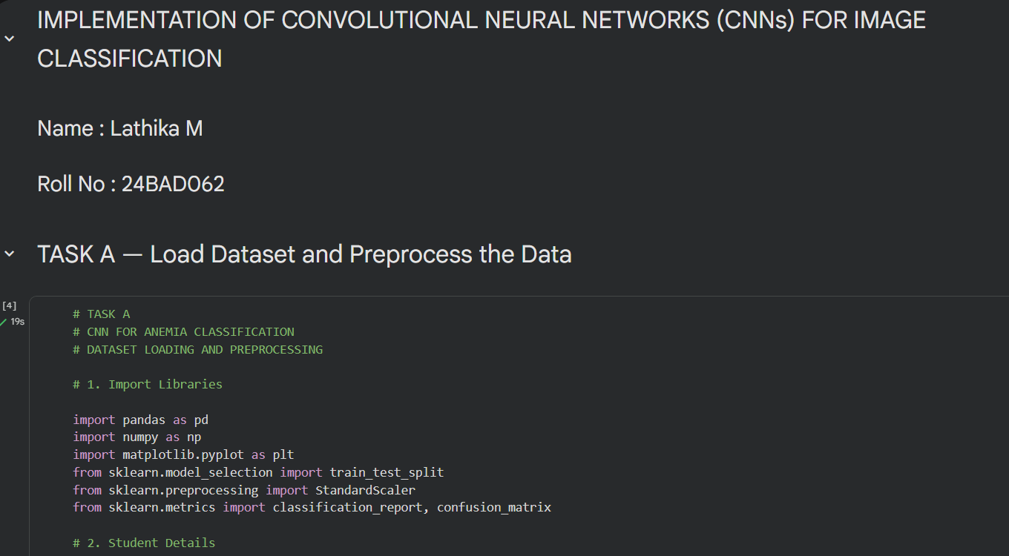

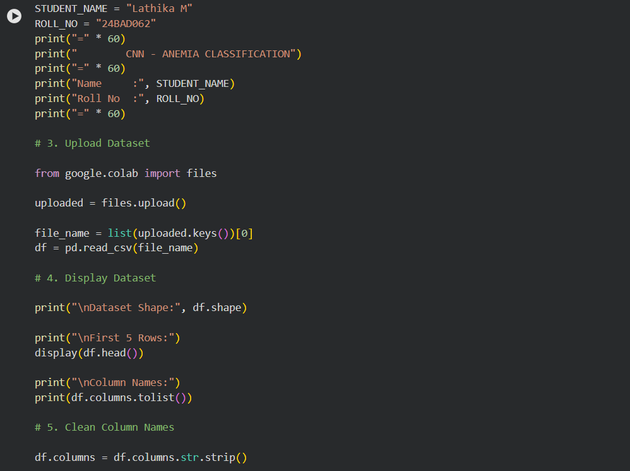

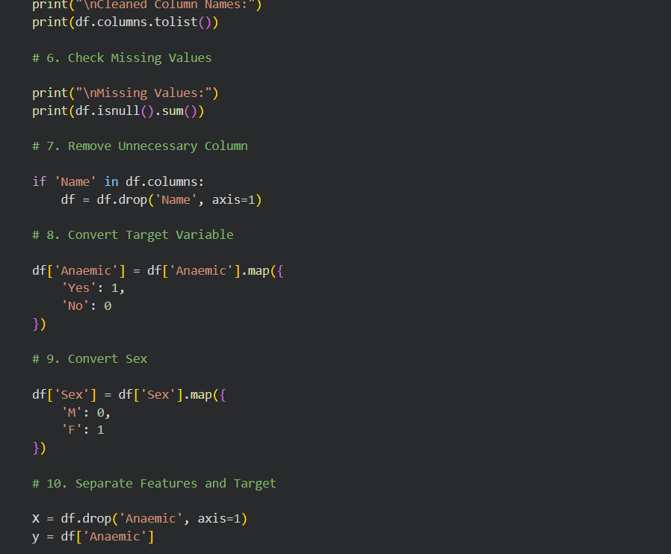

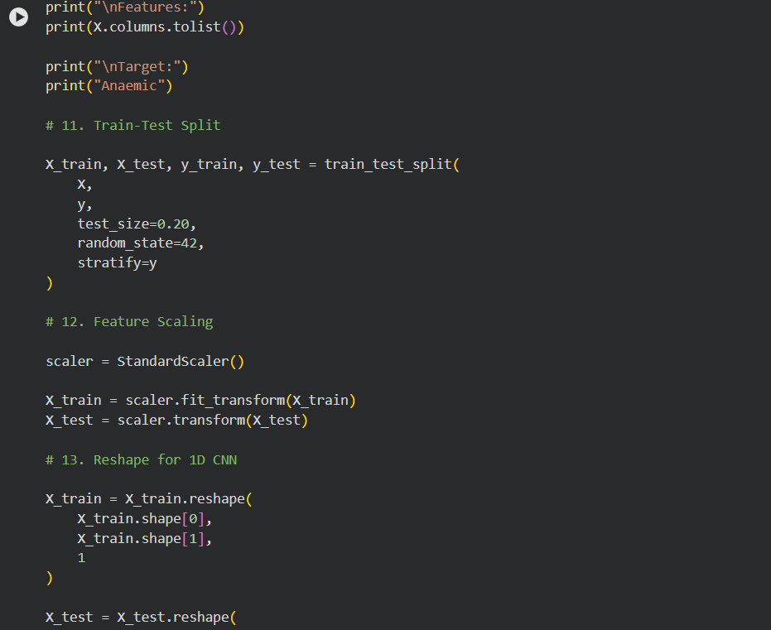

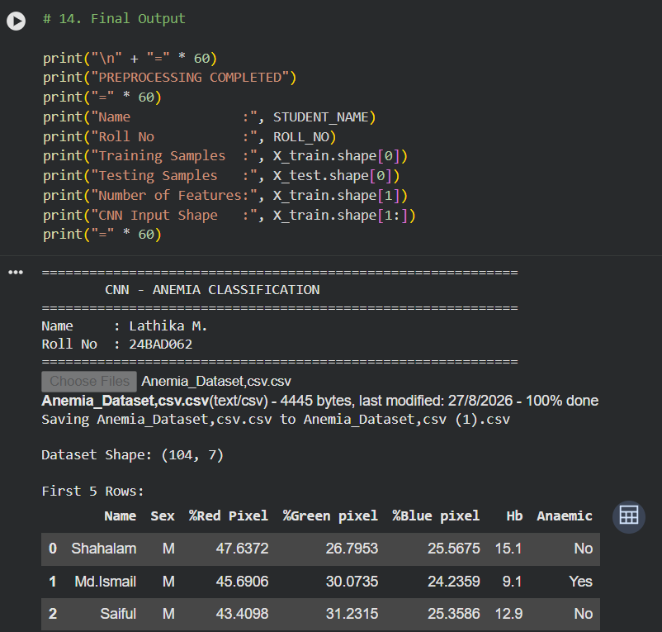

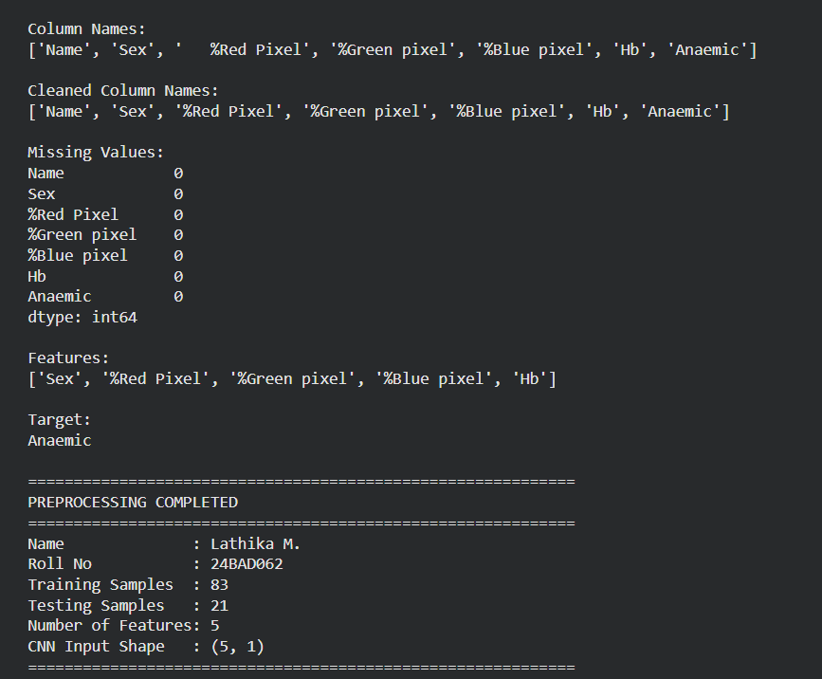

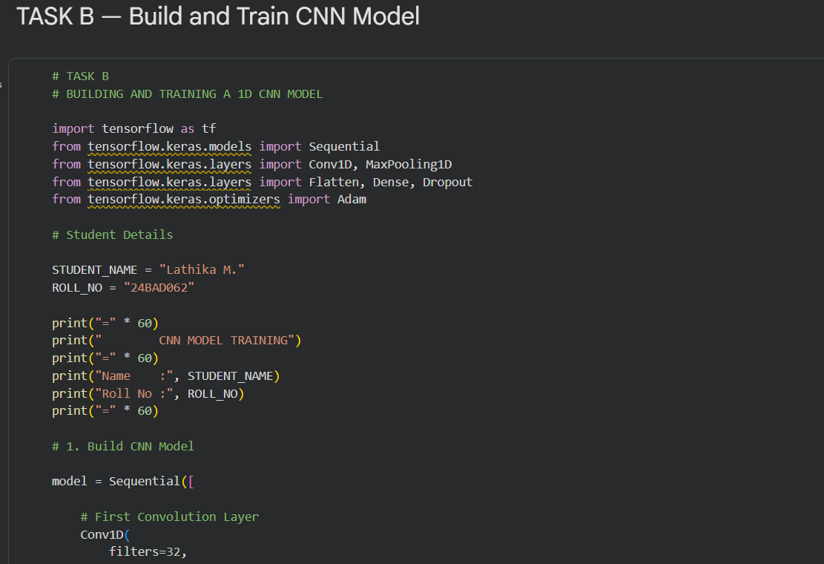

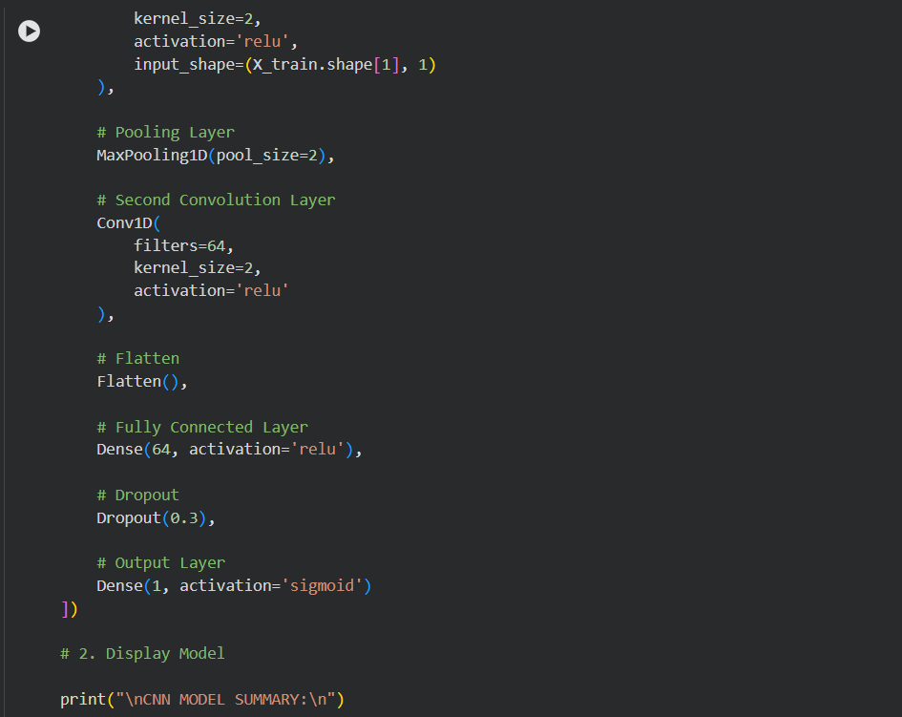

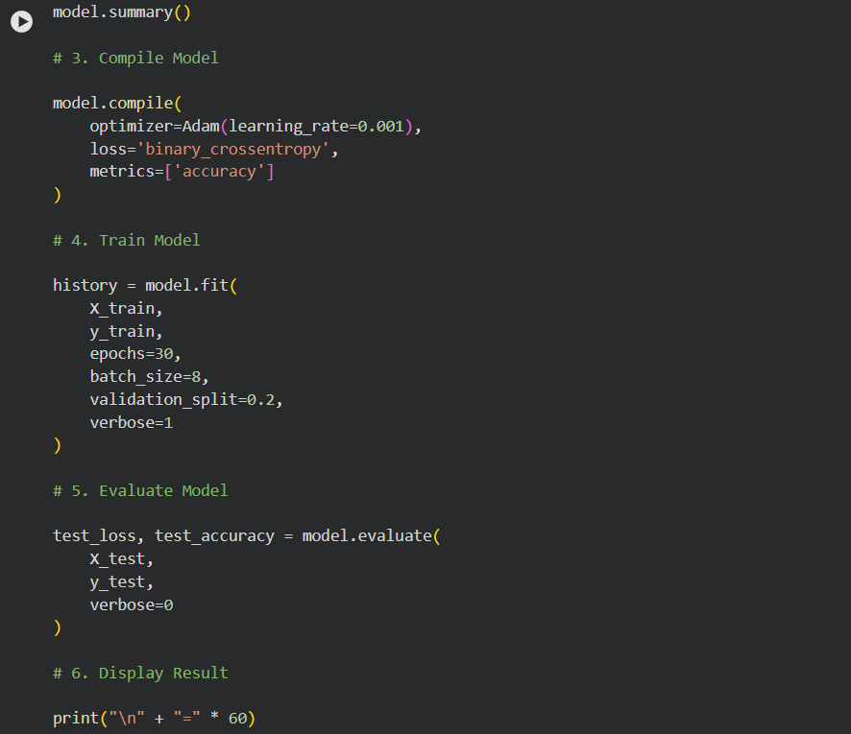

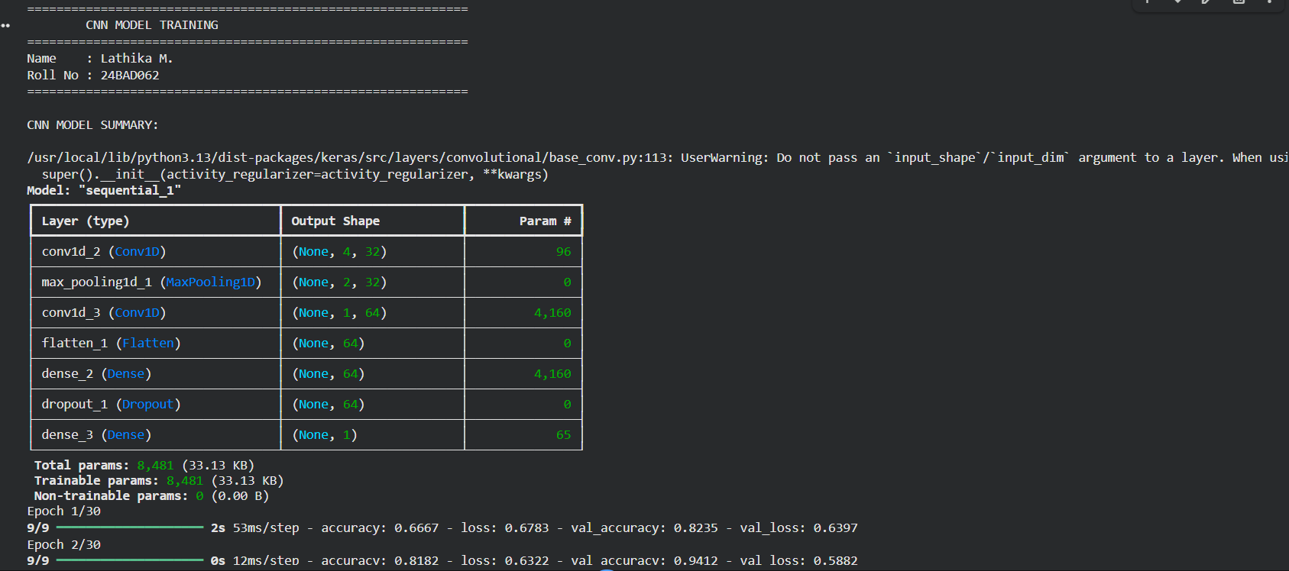

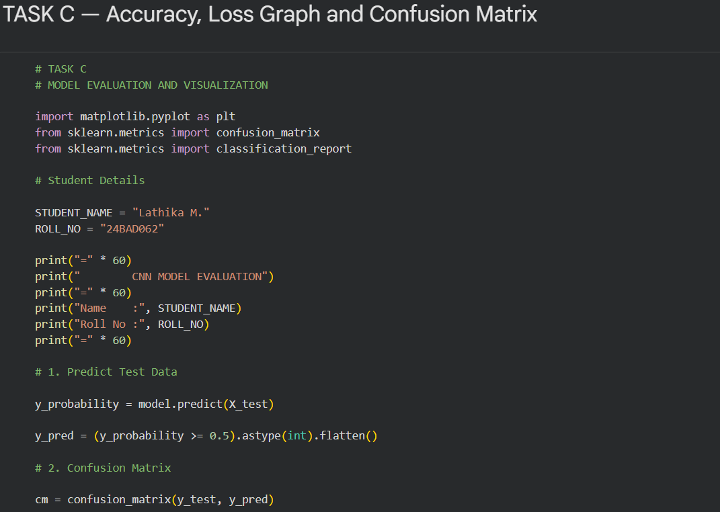

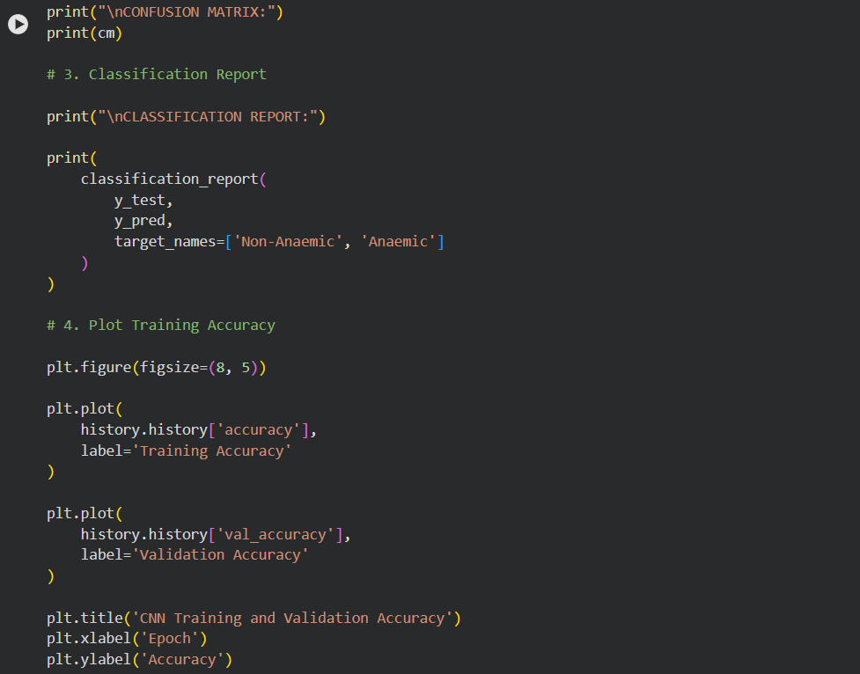

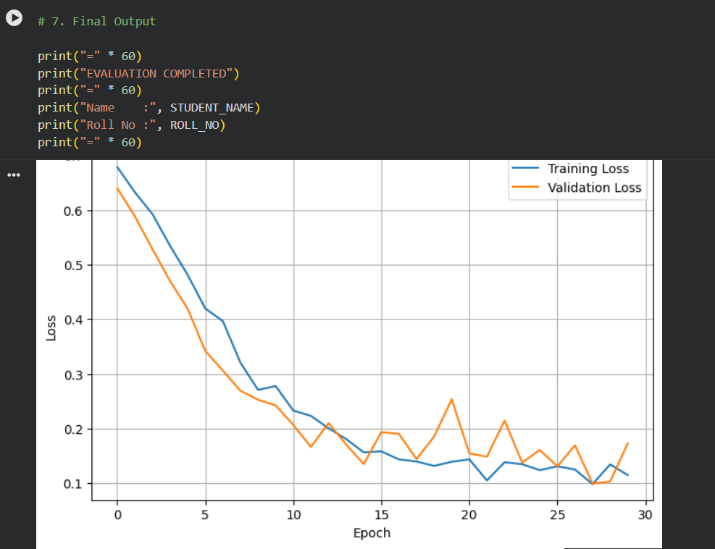

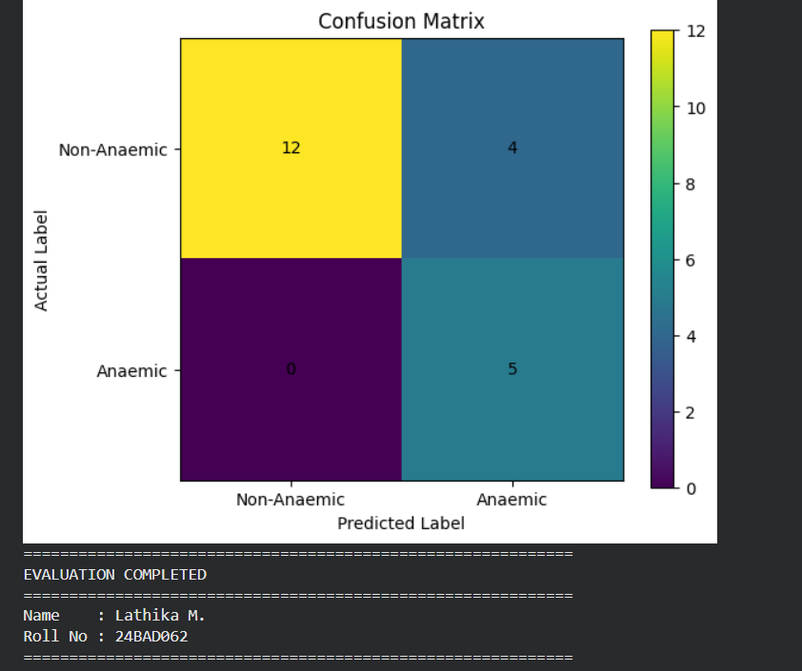

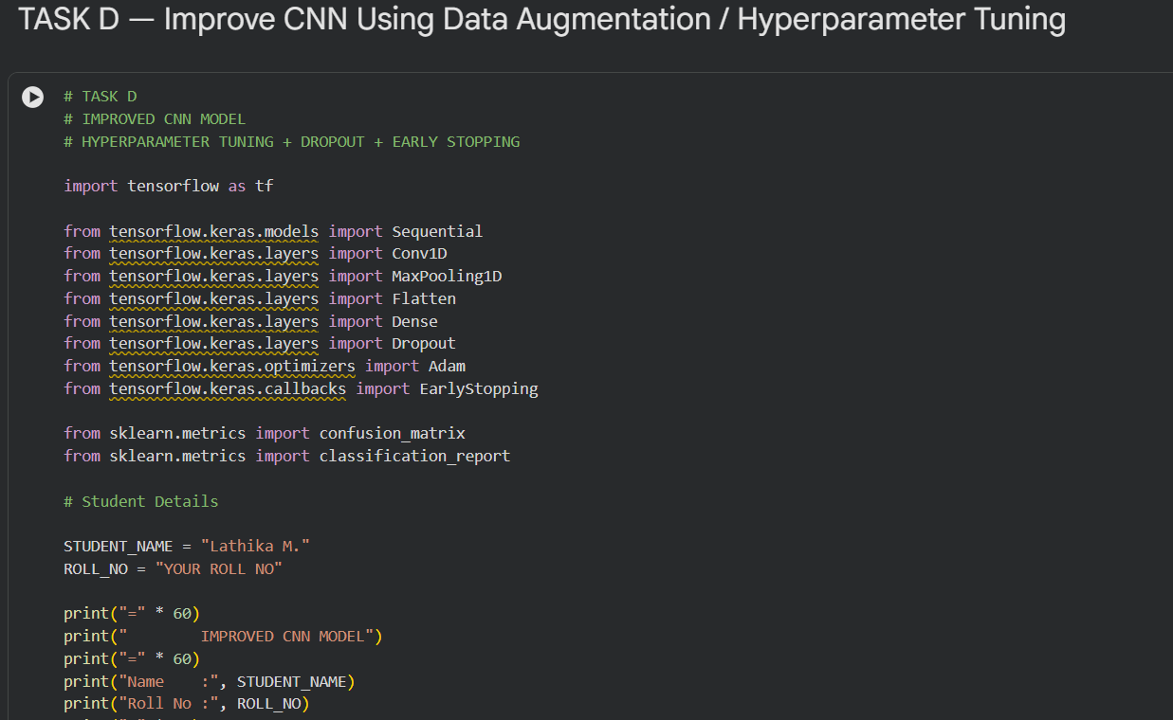

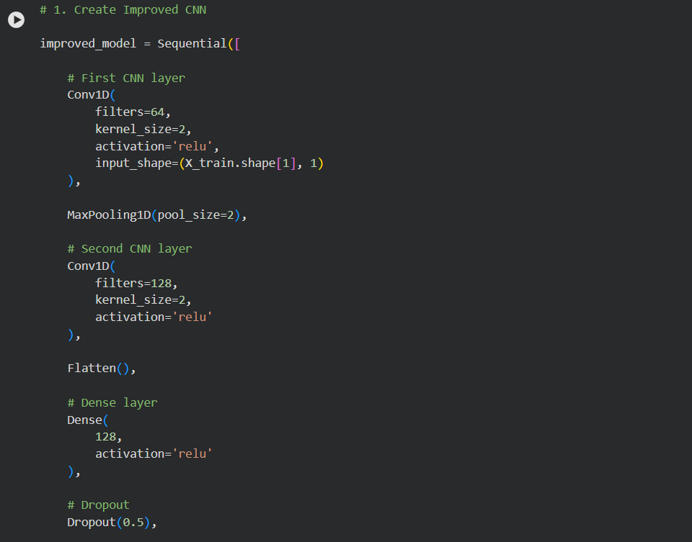

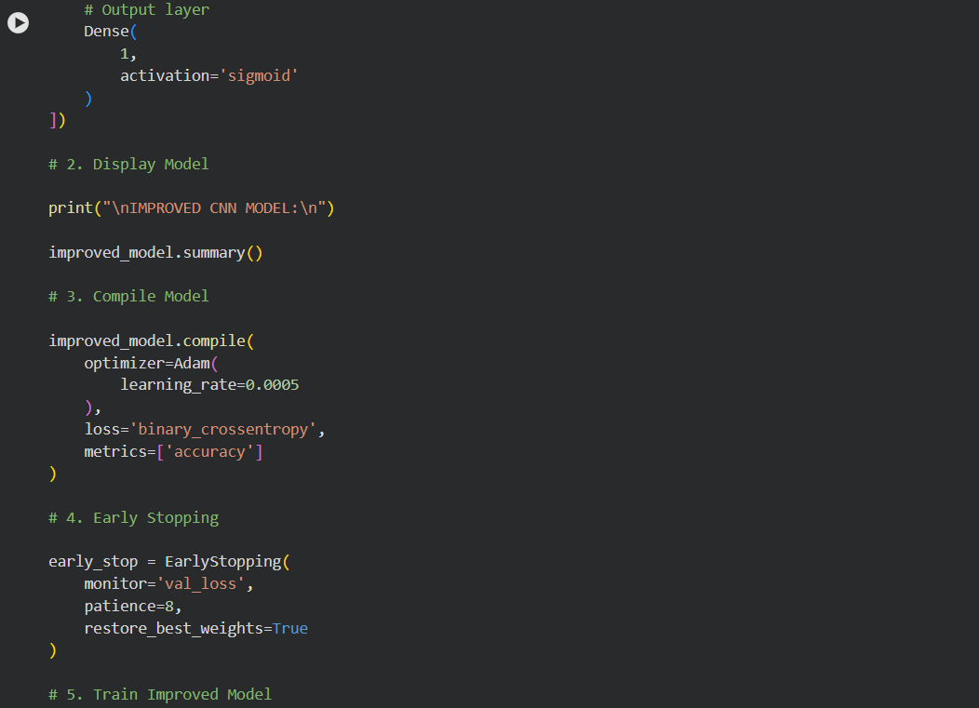

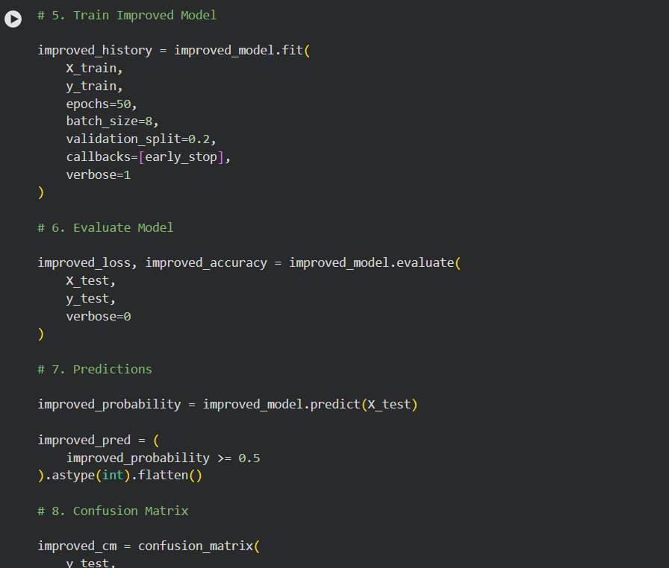

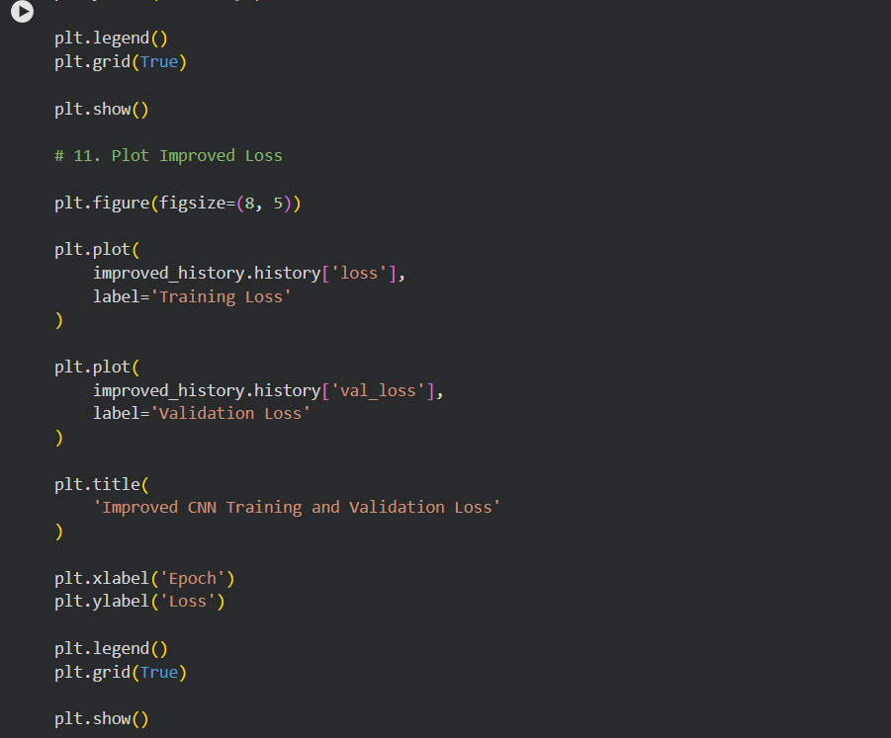

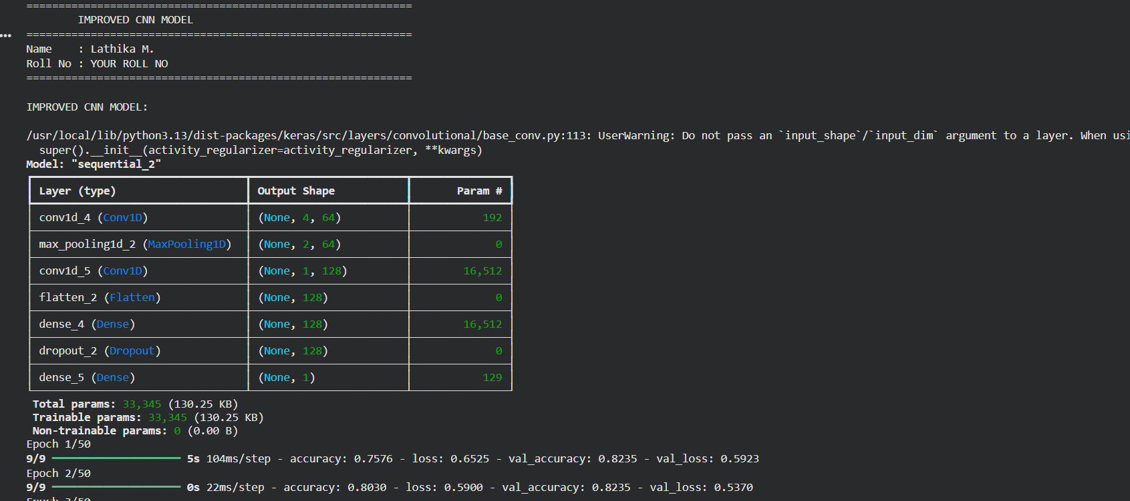

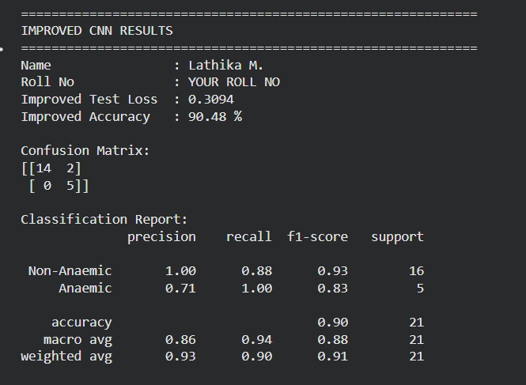
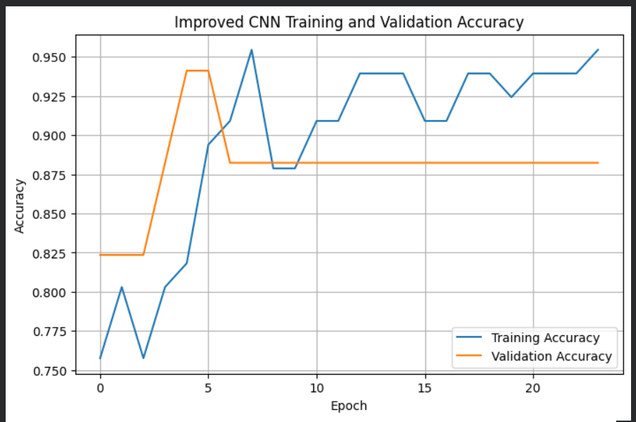

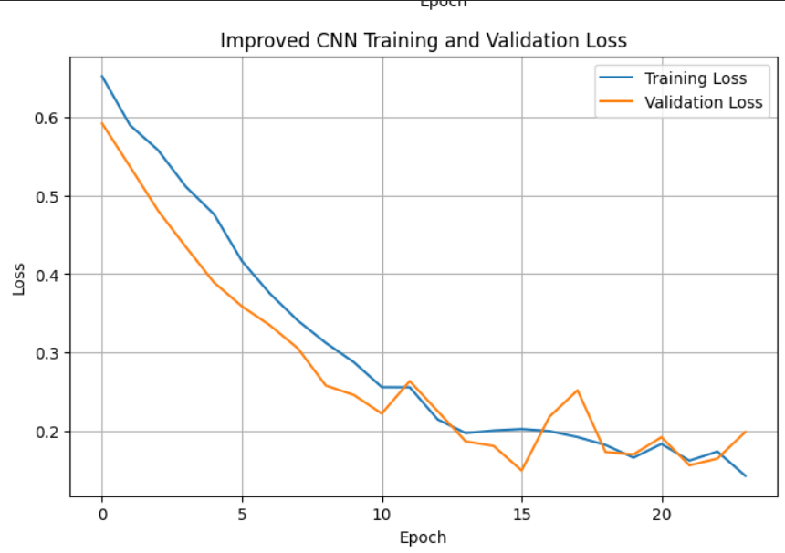
POST-LAB QUESTIONS (PROVIDE BRIEF ANSWERS TO THE FOLLOWING QUESTIONS)

1. Why are convolution layers more effective than fully connected layers for image processing?
Convolution layers are more effective because they preserve the spatial structure of images and focus on local features such as edges, textures, and shapes. They also use shared weights, which greatly reduces the number of parameters compared to fully connected layers.

2. How does Max Pooling improve CNN performance?
Max Pooling reduces the size of feature maps by selecting the maximum value from a small region. This reduces computational cost, keeps the most important features, and helps the model become less sensitive to small changes in the image.

3. Which hyperparameters significantly affected your CNN model performance?
The important hyperparameters include:

- Learning rate – controls how quickly the model learns.
- Batch size – affects training speed and stability.
- Number of epochs – determines how many times the model learns from the dataset.
- Number of filters and layers – affects the model's ability to learn complex features.
- Dropout rate – helps reduce overfitting.

4. What challenges did you encounter while training the CNN model?
Some challenges encountered were overfitting, long training time, selecting suitable hyperparameters, and achieving good validation accuracy. Choosing the appropriate learning rate and number of epochs was also important for obtaining better performance.

5. Suggest two improvements that can increase the classification accuracy of your CNN.
Two improvements are:
- Use data augmentation such as rotation, flipping, and zooming to increase training data diversity and reduce overfitting.
- Tune hyperparameters such as learning rate, batch size, number of layers, and filters to find the best-performing model.

ASSESSMENT
Description | Max Marks | Marks Awarded
Pre Lab Exercise | 5
In Lab Exercise | 10
Post Lab Exercise | 5
Viva | 10
Total | 30
Faculty Signature

